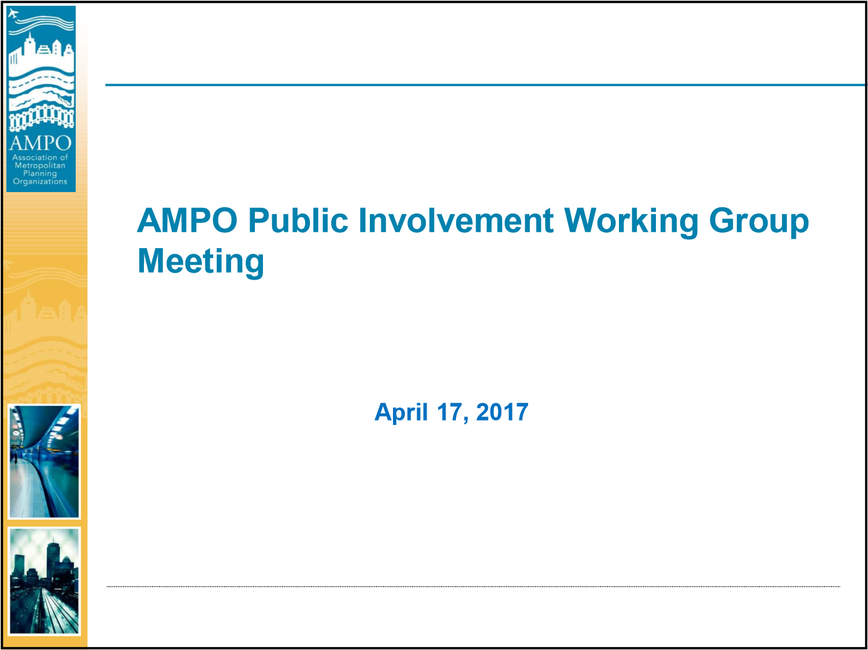
Agenda
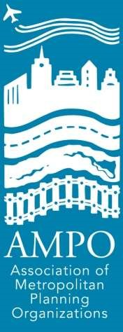
•Welcome and Introductions
•Background and Purpose
•Current and Emerging Issues
•Next Steps and Closing
2

Background and Purpose
Why a Public Involvement Working Group?
3
Background and Purpose
Mission and Goals Discussion
Mission: The AMPO Public Involvement Working
Group supports public involvement in metropolitan
transportation planning that meets federal
requirements and strengthens the delivery and stewardship of programs, projects, and the transportation system.
4

Background and Purpose
Mission and Goals Discussion
Goals:
– Provide a forum for communications and sharing of public involvement best
practices, guidance, and resources that support:
▪ Metropolitan Planning Organizations (MPOs) in meeting federal
requirements related to public involvement.
- MPOs in efficiently integrating public involvement into their programs, projects, and activities in a way that uses resources effectively.
- Public involvement practices that build public trust and relationships, and gain participation from a diverse group of stakeholders.
- The use a wide range of public involvement strategies, techniques, and methods to meet the diverse needs of MPO stakeholders, projects, programs, and activities.
- Identify opportunities, challenges, needs, and emerging issues in public involvement.
- Communicate and share best practices, guidance, resources, and activities with other AMPO committees and at AMPO events, as appropriate.
5
Background and Purpose
Website
•Mission and Goals
•Contacts
•Meetings and Events
•Resources
– Thanks to those who have already shared materials
6

Background and Purpose
Website - Resources:
• 23 Code of Federal Regulations (CFR) Part 450 Subpart C—Metropolitan Transportation
Planning and Programming http://www.ecfr.gov/cgi-bin/text-idx?rgn=div5&node
=23:1.0.1.5.11#sp23.1.450.c
• United States Department of Transportation (USDOT) Federal Highway Administration
(FHWA) Public Involvement https://www.fhwa.dot.gov/planning/public_involvement/
- USDOT Federal Transit Administration (FTA) Public Involvement and Outreach https://www.transit.dot.gov/regulations-and-guidance/transportation-planning/public involvement-outreach
- USDOT FTA Title VI of the Civil Rights Act of 1964 https://www.transit.dot.gov/ regulationsand-guidance/civil-rights-ada/title-vi-civil-rights-act-1964
- USDOT FHWA Environmental Justice https://www.fhwa.dot.gov/environment/ environmental_justice/
- USDOT FHWA Americans with Disabilities Act/Section 504 of the Rehabilitation Act of 1973 https://www.fhwa.dot.gov/civilrights/programs/ada.cfm
- USDOT FHWA and FTA Public Involvement Techniques, Chapter 1: Informing People Through Outreach and Organization, Section A: Including People Who Are Underserved by Transportation, Subsection a: Ethnic, Minority, and Low Income Groups and Subsection b: People with Disabilities https://www.planning.dot.gov/ PublicInvolvement/pi_documents/1intro.asp
7
Background and Purpose
Website - Resources continued:
• United States Department of Homeland Security A Guide to
Interacting with People who have Disabilities
https://www.dhs.gov/sites/default/files/publications/
guide-interacting-with-people-who-have-disabilties_09-26-13.pdf
- USDOT FHWA and FTA A Guide to Transportation Decision Making
https://www.fhwa.dot.gov/planning/publications/transportation_de cision_making/citizen01.cfm
- USDOT FHWA Public Involvement Techniques for Transportation Decision-Making
https://www.fhwa.dot.gov/planning/public_involvement/publication s/techniques/chapter00.cfm
**Please send us resources from your MPOs to post on the website!** Again thanks to those who have
already shared materials. ⁸

Background and Purpose
Other related activities
– The Public Involvement, Title VI, Environmental Justice, and Equity
in Practice session will be held at the AMPO Planning Tools and
Training Symposium in May in St. Louis.
- In preparation for the session, we have prepared a brief survey to help us get an idea of key topics and focus areas for the session presentations and discussions. If you have not already done so, please take a few minutes to fill out the survey: https://www.surveymonkey.com/r/T9SW5QN.
- More information on the AMPO Planning Tools and Training Symposium can be found on our website.
Determination of recurring quarterly meeting date and time
9
Current and Emerging Issues Discussion
Communication and Messaging Background:
What is an MPO? Explaining MPO functions to general audiences.
How to engage the public on performance measures and targets?
Leveraging the TIP--i.e. interactive practices, local awareness, and small business involvement.
10

Current and Emerging Issues
Evaluation of Outreach
Performance measures for public involvement. How effective is
your outreach?
11
Current and Emerging Issues Discussion
Federal Requirements and MPO Products
How to engage the public on performance measures and targets?
Leveraging the TIP—i.e. interactive practices, local awareness, and small business involvement.
12

Current and Emerging Issues Discussion
Stakeholder Groups
Other transportation agencies
Community organizations
The public
People with disabilities
Title VI and Environmental Justice
13
Current and Emerging Issues Discussion
Strategies, Techniques, Methods, and Tools
Using web-based and digital tools: webinars, websites, social
media (tagging other followers), and videos.
Using graphics--color, icons, and infographics.
Getting the public involved early.
Perspectives from small, medium, and large MPOs on:
-general public outreach activities
-getting comments on the TIP and UPWP -public outreach for the MTP
Public notices, newspaper placements, advertising (newspaper versus online media buyer), and sponsored ads
14

Next Steps and Closing
•Public Involvement Session at the AMPO
Symposium
•Public Involvement Working Group Webinar in
June
– Interested in presenting at the next or a future webinar please let us know!
15
Thank you
• Linda Alvarado-Vela, Alamo Area Metropolitan Planning
Organization
• Melissa Roberts, Atlanta Regional Commission
- Chris Ryan, Broward Metropolitan Planning Organization
- Amanda Wilson, North Central Texas Council of Governments
AMPO Contacts:
Rachel Roper rroper@ampo.org or 202-624-3682
Tiffany Currie tcurrie@ampo.org or 202-624-3686
16

