Making a Plan for Our Region
2016

Chicago is the third largest U.S. metropolitan region.
Developed area, 1900-2005

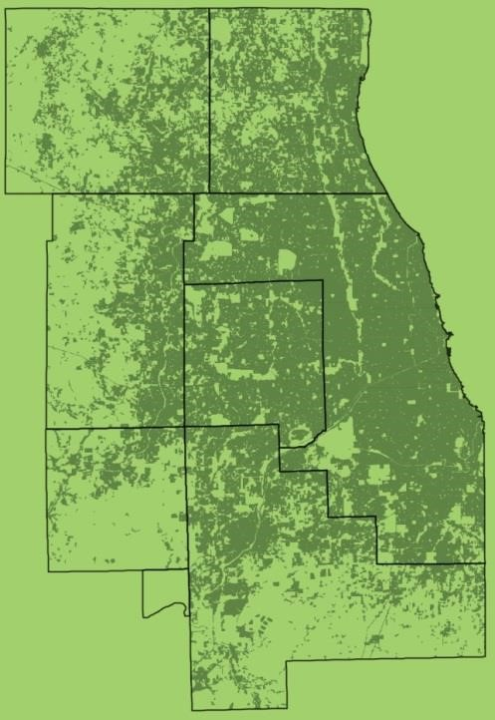
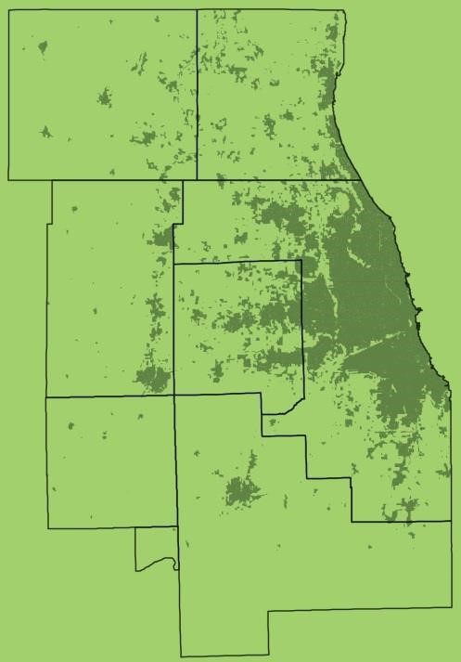
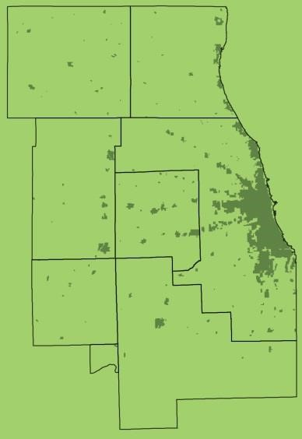
Source: U.S. Environmental
Protection Agency and Chicago Metropolitan Agency for Planning.
1900 1950 2005
The northeastern Illinois region
8.5 million people | 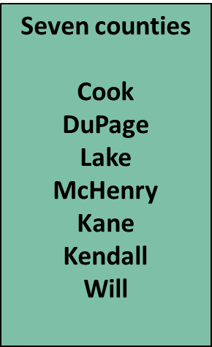
284 cities and villages

2.6 million acres

Our region’s communities are changing. . . .
- Demographics: racial and ethnic diversity, age, immigration
- “Rare” storm events
- Travel behavior
- Land use stresses
- Constrained water supply
- Suburbanization of poverty
- Housing supply, affordability
- Diminished public resources
- Interconnected regional economy
- Advances in technology
- Segregation of communities
Our communities implement the local plans we develop together.
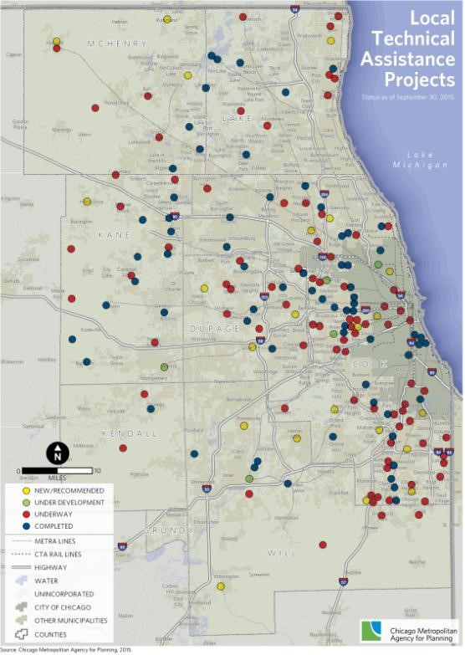
Bicycles/Pedestrian Paths Land Use
Business Districts Livability
Capital Improvement Neighborhoods
Commercial Markets Parking
Community Vision Parks
Corridors Public Land
Downtowns Retail Land Use
Draught Preparedness Retail Market
Economic Development Sidewalks
Strategy Subareas
Feasibility studies Sustainability
Food Access Transportation Access
Health Impact Water Conservation
Housing Investment Watershed
Housing Policy Zoning
We ask our communities how they envision their futures.
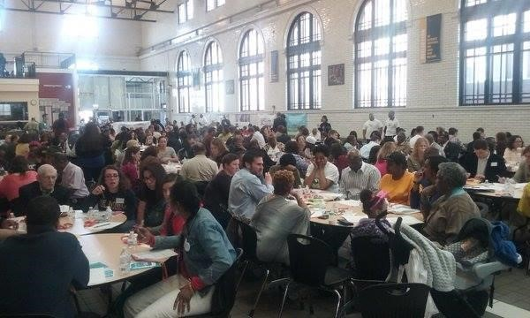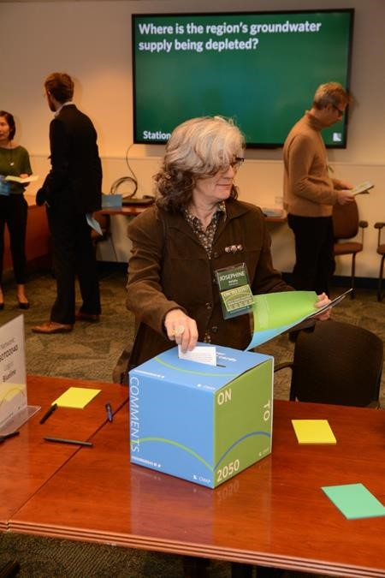
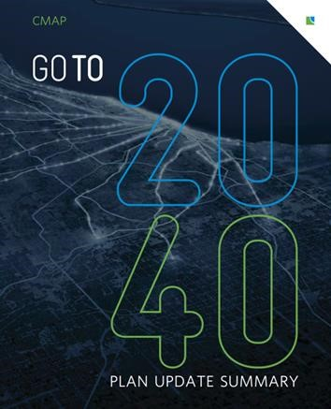
CMAP also creates big plans for our region.
GO TO 2040 and ON TO 2050
- Public input
- Three years to develop
- Approved by CMAP Board
You are regional:
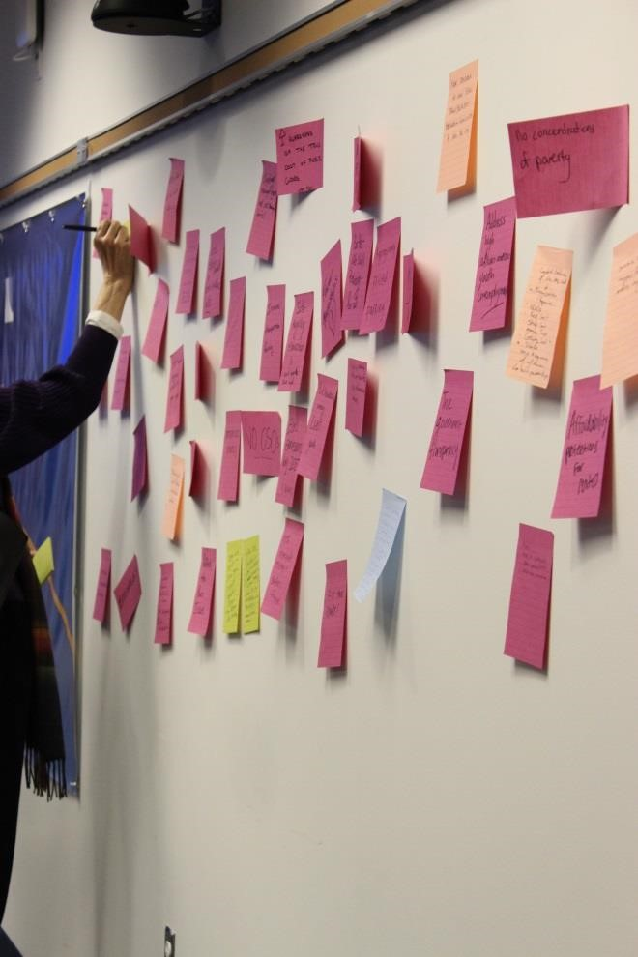
- Residents
- Taxpayers
- Employees
- Commuters
- Family members
- Drivers
- Walkers
- Shoppers
- Investors
How to use the keypads.
- Votes are anonymous.
- Your last vote is the vote that counts.
- Return the keypad, please.
Think regional, about our future.

Have you heard of CMAP?

0% A. Yes, of course
0% B. Whaa?
0% C. CMAP, CMAP, CMAP. Enough _{already.} 0% D. Is it a software company? Subhead goes here
E. My auntie had it, but she’s better now.
0
%
What is your primary way to get around?
0% A. Car
0% B. Walk
0% C. Bike
^{0% D. Bus} Subhead goes here
CTA train
Metra train
G. Other
0
%
0
%
0
%
E.
F.
How would you prefer to get around?
0% A. Car
0% B. Driverless car
0% C. Walk
0% D. Bike
Subhead goes here
0% E. Bus
0% F. Train
0% G. Boat
0% H. Other

transportation, what is our
biggest regional challenge?
0% A. Condition of existing infrastructure
0% B. Funding for upgrades, modernization
0% C. Roadway and freight/rail congestion
Subhead goes here
0% D. Transportation connections
0% E. Prioritizing transportation investments
0% F. Other

land use, what is our
biggest regional challenge?
- Infill development is more expensive than developing rural land
0
%
0
%
- Attracting investment to urban and suburban downtowns
Subhead goes here
0
%
0
%
- Community acceptance of higher density housing and rental residences
- Low demand for new development in isolated communities
0% E. Other
economic development, what is our biggest regional challenge?
A. Segregation of communities
- Attracting the first investor to a place Subhead goes here
- Access to good jobs for all residents
- Competition among municipalities
- Supporting existing businesses and talent F. Other

For the environment, what is our biggest regional challenge?
0% A. Depletion of groundwater resources
0% B. Loss of green space, habitat, agricultural land
0% C. More temperature extrem^{Subhead goes here}es
0% D. Flooding and stormwater management
0% E. Other
For housing, what is our biggest regional challenge?
0% A. Affordability
0% B. Housing stock variety for all life stages
0% C. Available housing is far froSubhead goes herem public transportation
0% D. Other
For governance, which is our biggest regional challenge?
- Too many governmental units
- Governments can’t provide services residents need
- Antiquated tax policies
Subhead goes here
- Coordination among governments
- Dysfunction in state government
- Other
If we seek sustainable prosperity and quality of life for the region, what are your top four priorities to address?
0% A. Economic development
0% B. Education
0% C. Equity
0% D. GovernanceSubhead goes here
0% E. Housing
0% F. Public safety and crime
0% G. Transportation
0% H. Other
In economic development, where is our best opportunity?
0% A. Align education with workforce needs
0% B. Encourage coordination among municipalities
% C. Invest in innovationSubhead goes here
For transportation, where is our best opportunity?
A. Ensure sufficient, sustainable revenue B. Leverage technology for better traffic management
0
%
0
%
- Invest in bicycle and p^{Subhead goes here} edestrian systems
0
%
0
%
0
%
- Expand public transportation
- Other
In land use, where is our best opportunity?
- Focus investment in transit areas, downtowns, job centers
0
%
0
%
- Prioritize preservation of agricultural land, open space
^{0%} C. Encourage cross-border collaboration on development Subhead goes here
- Locate new housing close to transit, jobs
0
%
0
%
- Other
For the environment, where is our best opportunity?
0% A. Build climate-resilient infrastructure
0% B. Use best practices for greenfield development
0% C. Update building codes, etc., for climate change
0% D. Support biodiversity and cSubhead goes here onservation
0% E. Use more green infrastructure
0% F. Increase use of renewable energy
0% G. Other
In housing, where is our best opportunity?
A. Coordination among regional jurisdictions on housing
0
%
0% B. Update and simplify regulation on development
projects to reduce costsSubhead goes here
0% C. Incentive affordable housing, including rehab of older housing stock
0% D. Other
In governance, where is our best opportunity?
A. Consolidation of governmental units
0% B. Term limits
0
%
0% C. Sharing of services among cities
Subhead goes here
0% D. More civic education, informed voting
0
%
0
%
- Nonpartisan legislative maps
- Other
How do you feel about the region’s future for prosperity and quality of life?
- Great!
0
%
0
%
0
%
0
%
0
%
- Good, but we have some work to do
- OK, but only if we av^{Subhead goes here}oid disaster
- We’re on a downward trajectory.
- No comment
What are our region’s three biggest assets?
- Our human capital
- National freight hub
- Educational institutions
- Transportation systems
- Natural resources^{Subhead goes here}
- Tourist attractions
- Lake Michigan
- Broad economic base
- Other

Help us anticipate and imagine our challenges and opportunities.
Stormwater
Industry management Economic
investment
Connection to
transportation Connection
to jobs Demographic
trends
Water resources
Housing Natural and Public policy choices agricultural areas and tax policy
More opportunities for participation:
Summer 2017
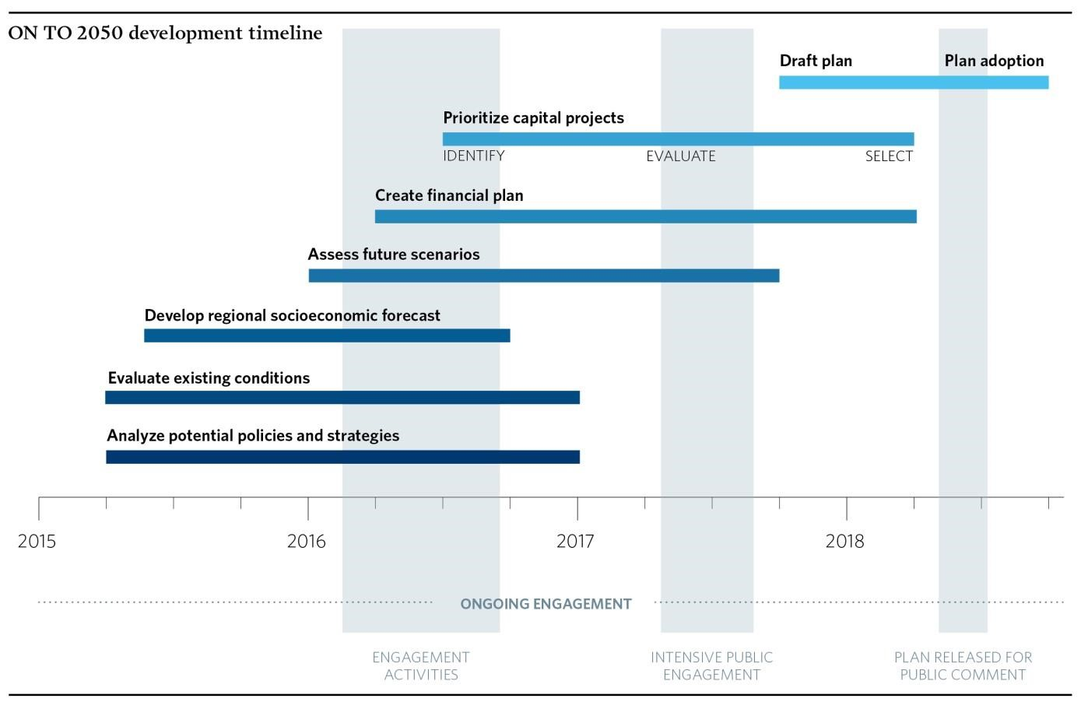
Future scenario planning
Summer 2018 Public comment on draft ON TO 2050 plan
October 2018
Approval by CMAP
Board
Stay in touch, stay tuned, let us hear from you and your constituents.
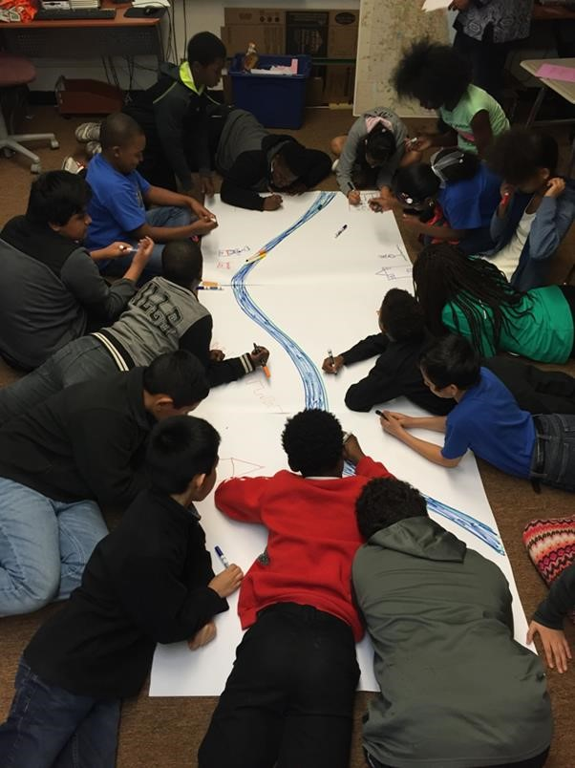
- Email us at onto2050@cmap.illinois.gov
- Subscribe to the CMAP Weekly Update
- Follow us on Twitter
@ONTO2050, like us on
Facebook, and share your
#2050BigIdeas
- Visit cmap.illinois.gov/onto2050 and stay up-to-date on the plan’s development
- Stay tuned. . . .

Thank you.

% D. Reform the tax structure 0% E. Reduce segregation among communities 0% F. Other

