Alternative Futures for our Region

Chicago is the third largest U.S. metropolitan region.
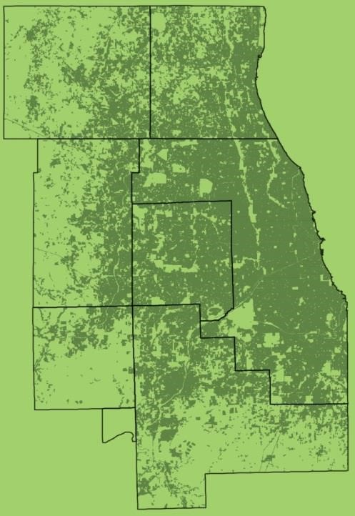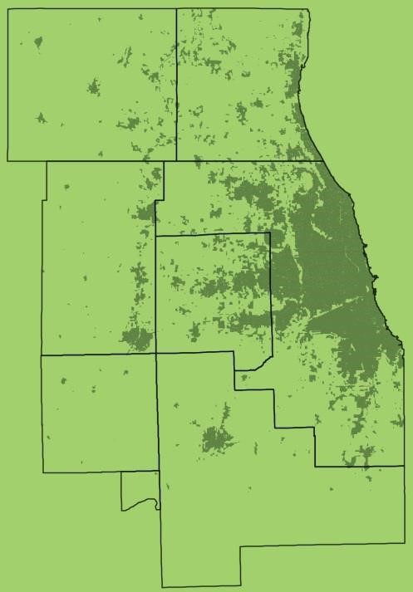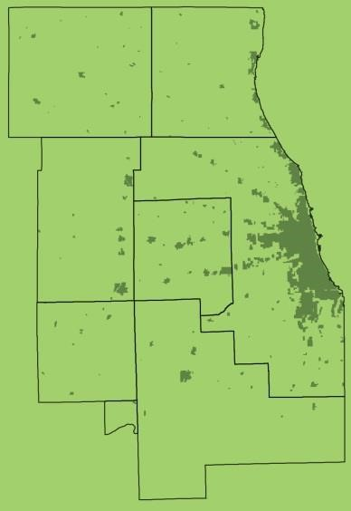
1900 1950 2005
We ask our communities how they envision their futures.
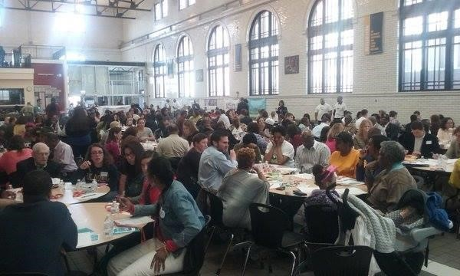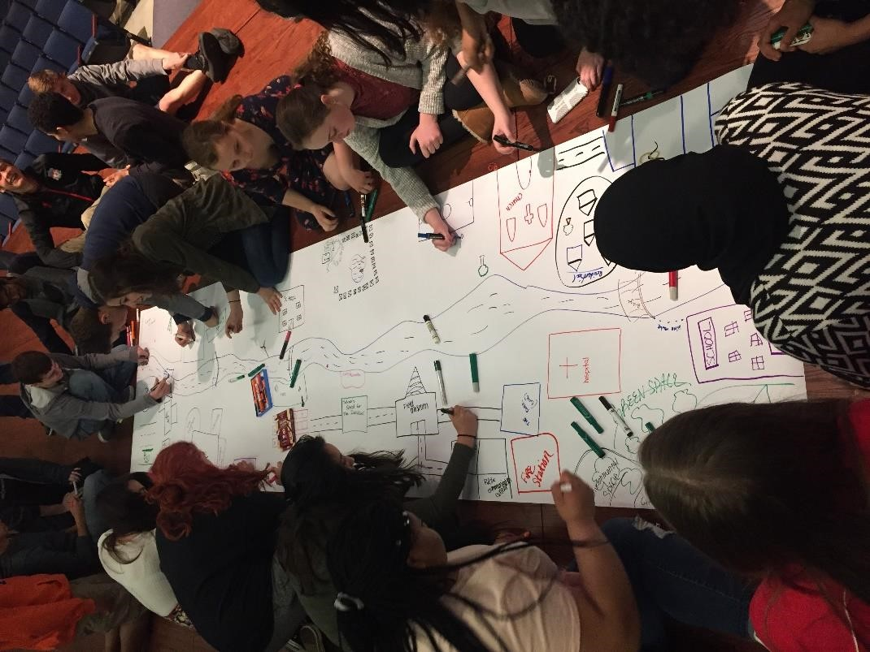
ON
TO
2050

The five alternative futures
- Changed Climate
- Walkable Communities
- Innovative Transportation
- Constrained Resources
- Transformed Economy
How to use the keypads
- Votes are anonymous.
- Your last vote is the vote that counts.
- Return the keypad, please.
Think regionally about our future.
What do you know about
CMAP?
Is it something to do with maps?
  - Make no little plans, they say
0
%
0
%
0
%
0
%
0
%
A.
  - Stands for Chicago Metropolitan Agency for
Planning
Subhead goes here
  - You’re a partner with local communities
  - All of the above

How old are you?
    - 0-19
    - 20-29 C. 30-39 D. 40-49
    - 50-59
    - 60-69Subhead goes here
    - 70-79
    - 80+

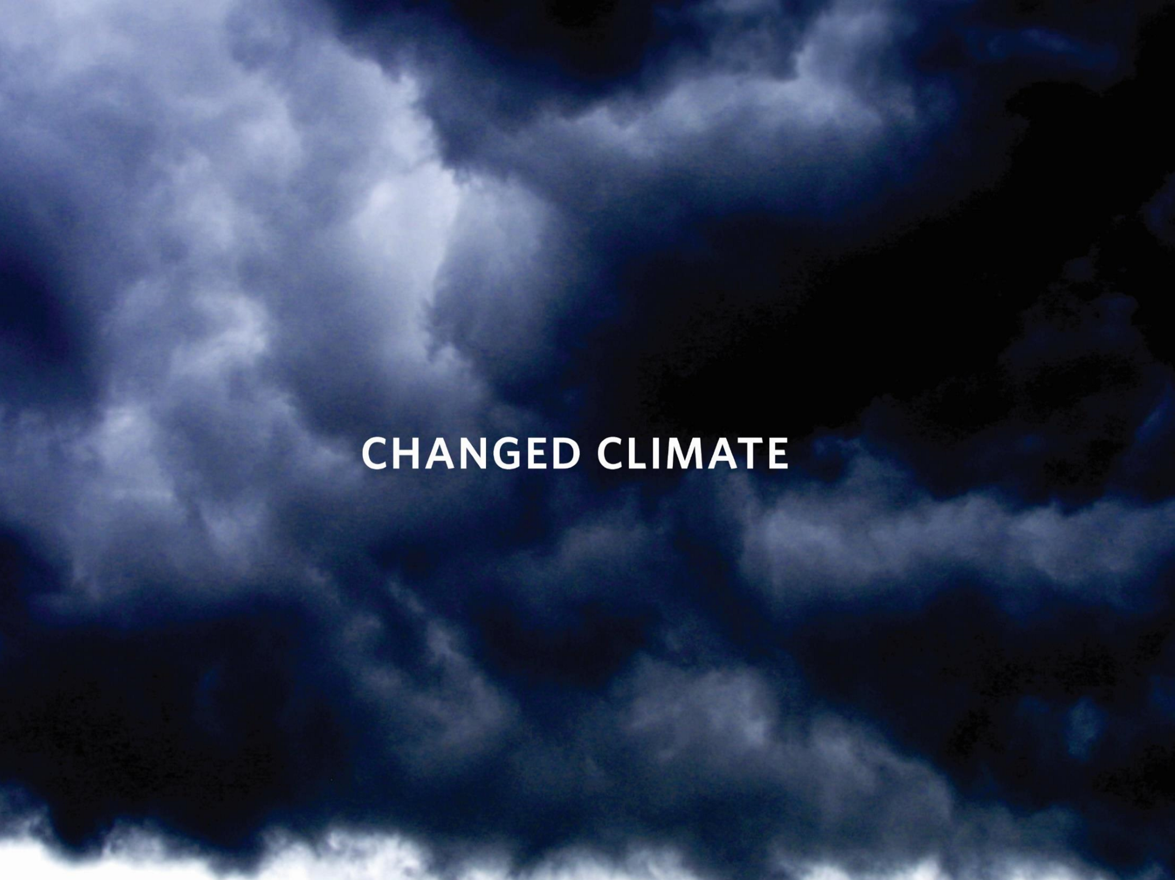

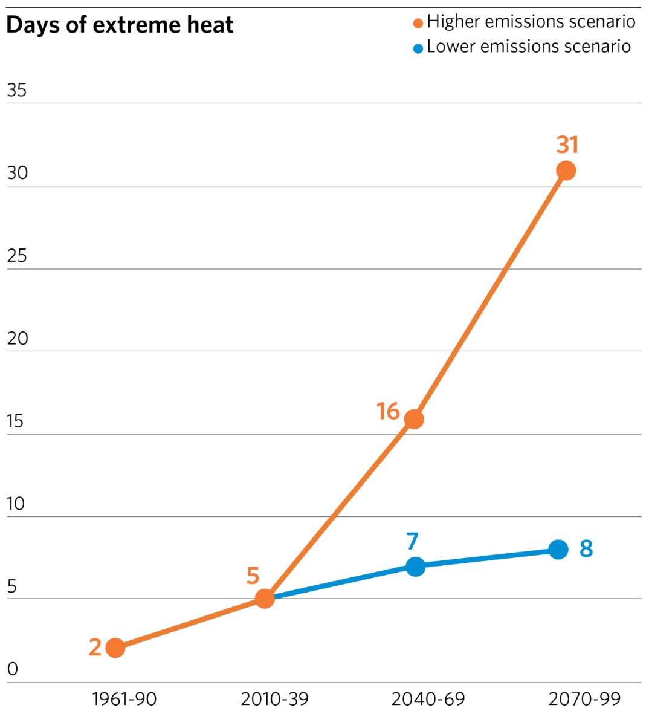
If the effects of climate change intensify . . .
•
More frequent and
intense storms
•
Prolonged drought
•
Warmer
temperatures
•
More extreme
temperatures
(
source: Chicago Climate Action Plan
)

As climate change intensifies, which impact worries you most in our region?
  - Harm to life and property from storms, flooding
0
%
0
%
0
%
0
%
0
%
0
%
0
%
  - Insufficient water supply
  - Threats to regional agriculture, biodiversity
  - Effect of extreme heat on healtSubhead goes hereh
  - More intense impacts for vulnerable residents
  - I’m not worried
  - Other
What is the biggest barrier to action on climate issues?
0% A. Doubt that climate change is real
0% B. The issue is too complex and abstract
0% C. Lack of urgency due to competing priorities
0% D. Limited understanding
0% E. People don’t know what theSubhead goes herey can do about it
0% F. Other
Which 2 of our regional systems are the most important to protect from climate impacts?
- Roads, bridges, and public transit
0
%
0
%
0
%
0
%
0
%
0
%
0
%
0
%
- Energy supply and distribution network
- Hospitals and emergency services
- Natural Subhead goes hereresources and open spaces
- Infrastructure for water supply and stormwater
- Our sources of water
- Food supply
- Other

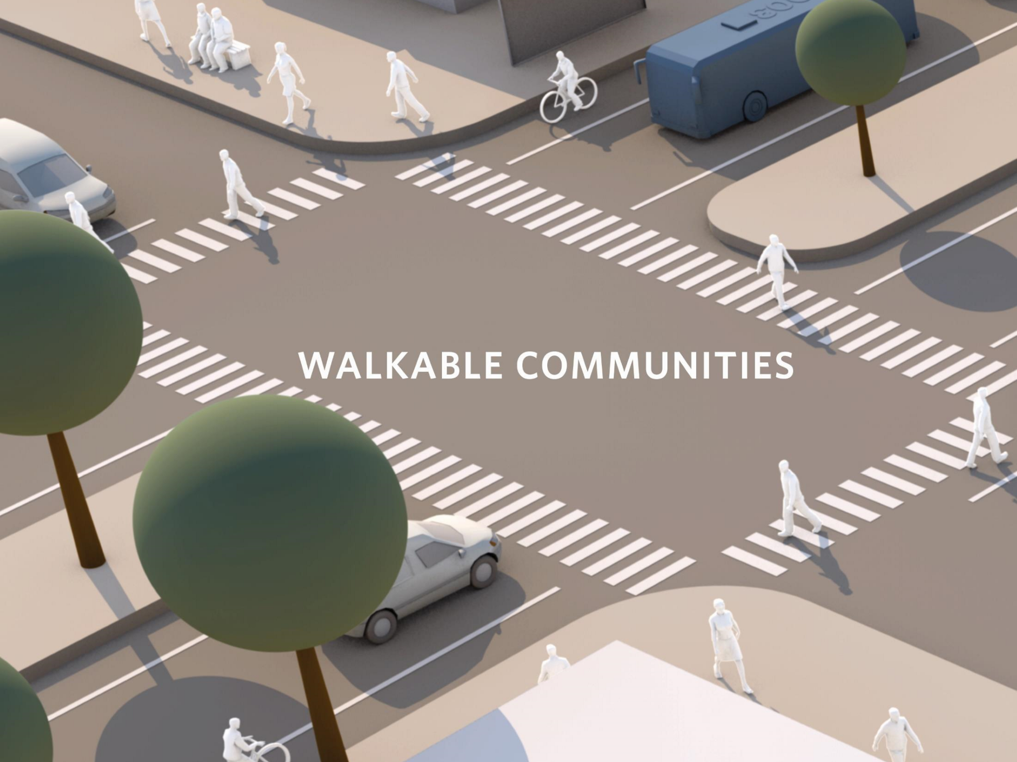

A shift to walkable communities . . .

- Preferences of today’s seniors and millennials
- Less reliance on cars
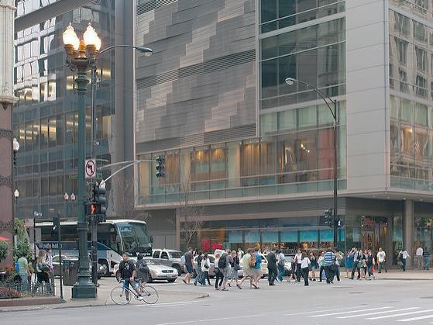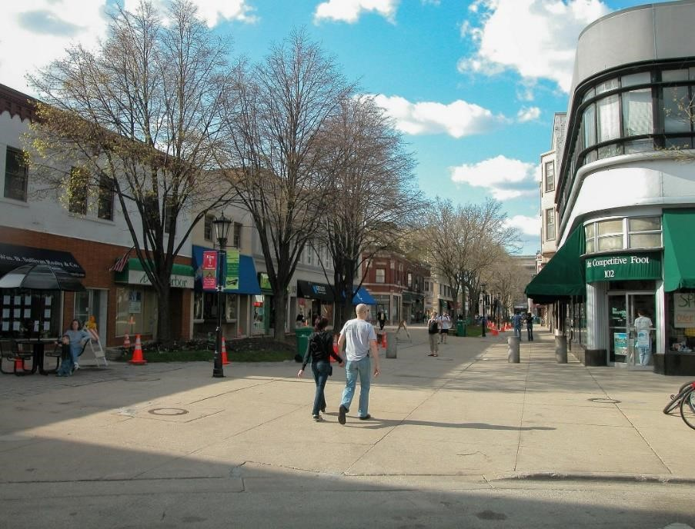
Source:
Flick
r
,
Chicago
Source:
Flick
r
,
Oak
Park
What are the 3 biggest benefits of more walkable communities?
0% A. Healthier residents
0% B. The ability to live car-free
0% C. More social interaction
0% D. Lower emissions mean less pollution Subhead goes here
0% E. Transportation costs less
0% F. More economic development in those places
0% G. Other
What type of housing does your community need most?
- For residents at all income levels
0
%
0
%
0
%
0
%
0
%
0
%
0
%
0
%
- For middle-income households
- For lower-income households
- For families
Subhead goes here
- For young professionals
- For a specific group
- We don’t need more housing types
- Other
What’s your top concern about denser, more walkable neighborhoods?
- I’m not concerned
0
%
0
%
- Changes to neighborhood character
0% C. More_{Subhead goes here} traffic and parking hassles
0% D. More stress on schools
0% E. Increased costs to residents
0
%
F. Other

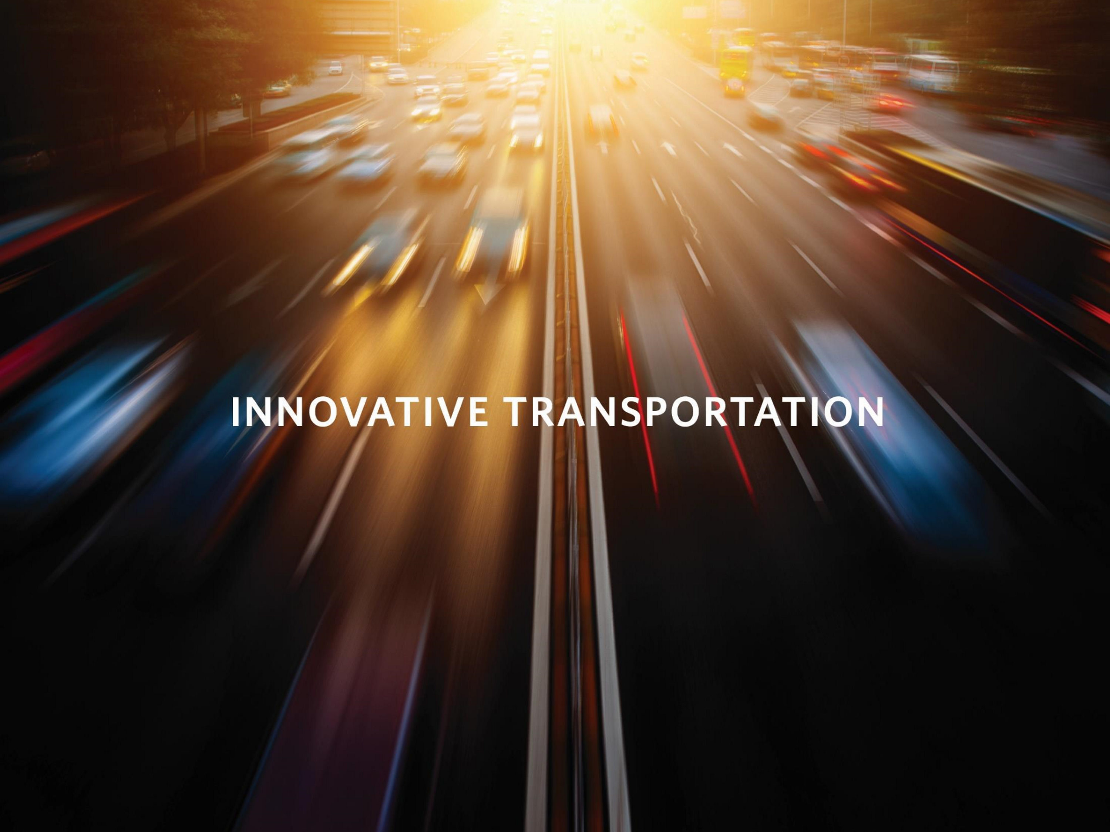

If technology enhances transportation . . .

- Congestion and route information at your fingertips
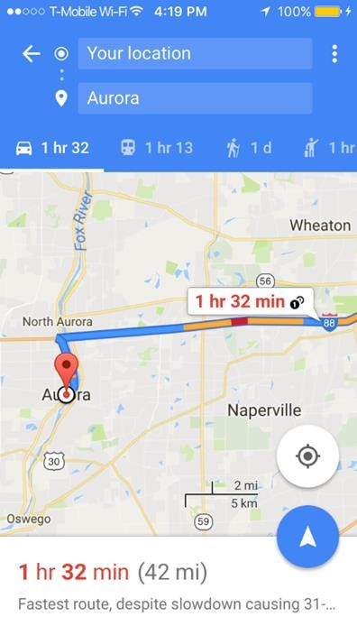
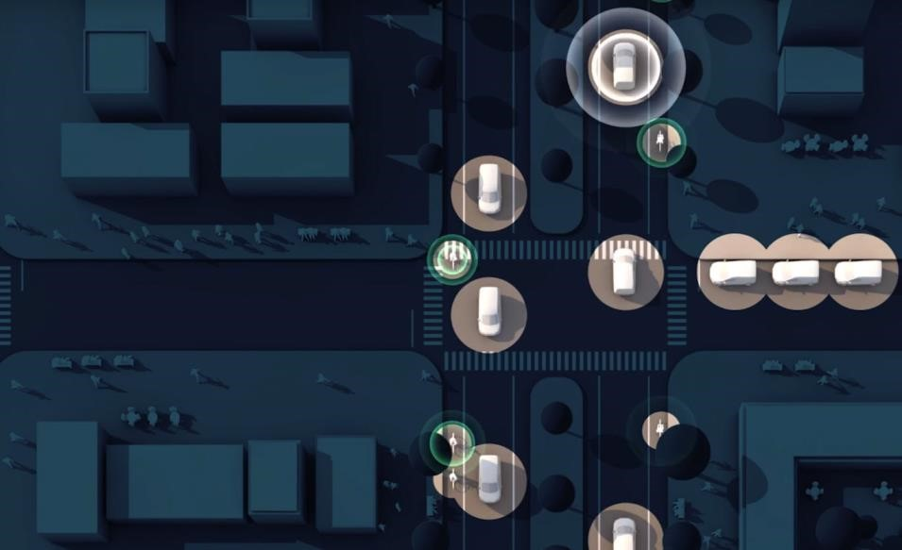
- Automated vehicles
- Instant gratification shopping (same-day delivery)
How comfortable are you with autonomous vehicles?
0% A. Very – can’t happen soon enough
0% B. Somewhat – they need more testing
0% C. Not at all
0% D. Will always prefer to drive my own car
0% E. _{Other} Subhead goes here
If fewer people own cars, we will need to invest in public transit. Which should be our top 2 priorities?
0% A. New bus/rail routes and extended rail lines
0% B. Service later at night
0% C. Shorter wait times
0% D. More reliable serviceSubhead goes here
0% E. Faster travel (such as bus express lanes)
0% F. Easier transfers and connections
0% G. More comfortable vehicles and stations
0% H. Other
If you had a convenient commute no matter where you lived, where would you choose to live?
0% A. An urban neighborhood
0% B. A walk_{Subhead goes here}able suburban community
0% C. A suburban subdivision
0% D. A small town
0% E. A rural area
0% F. Other

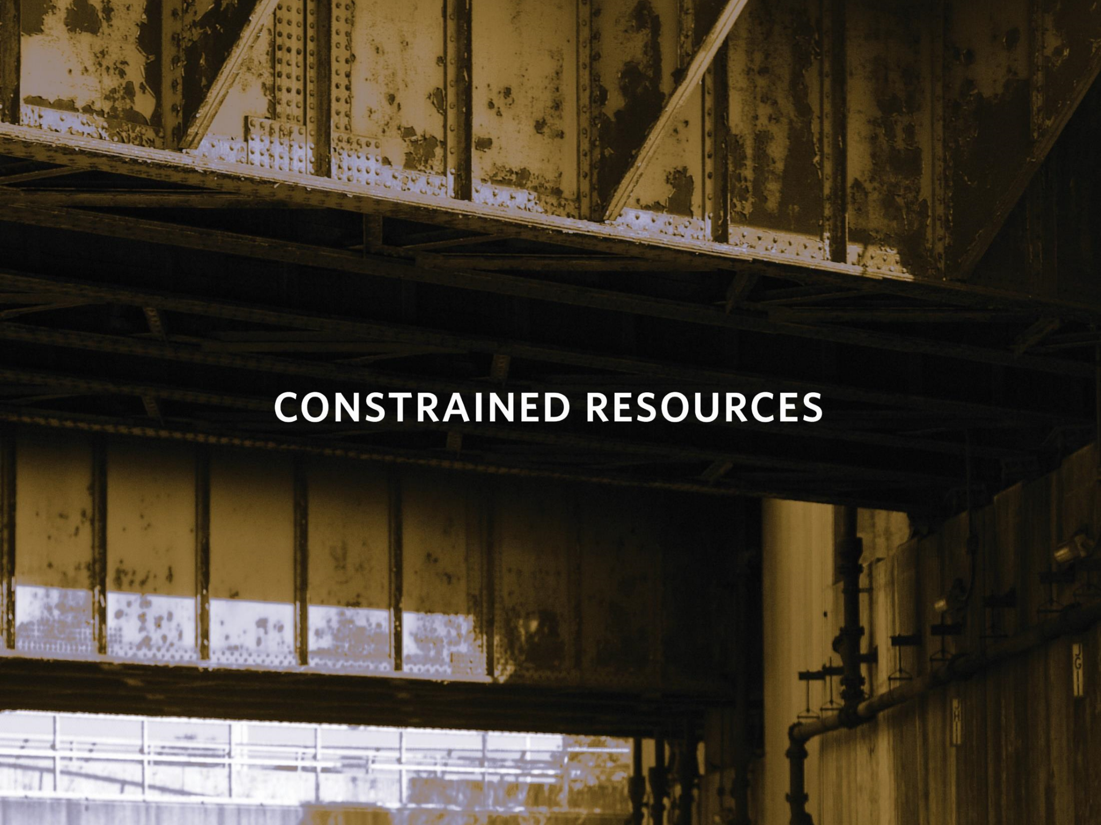

If public resources diminish further…
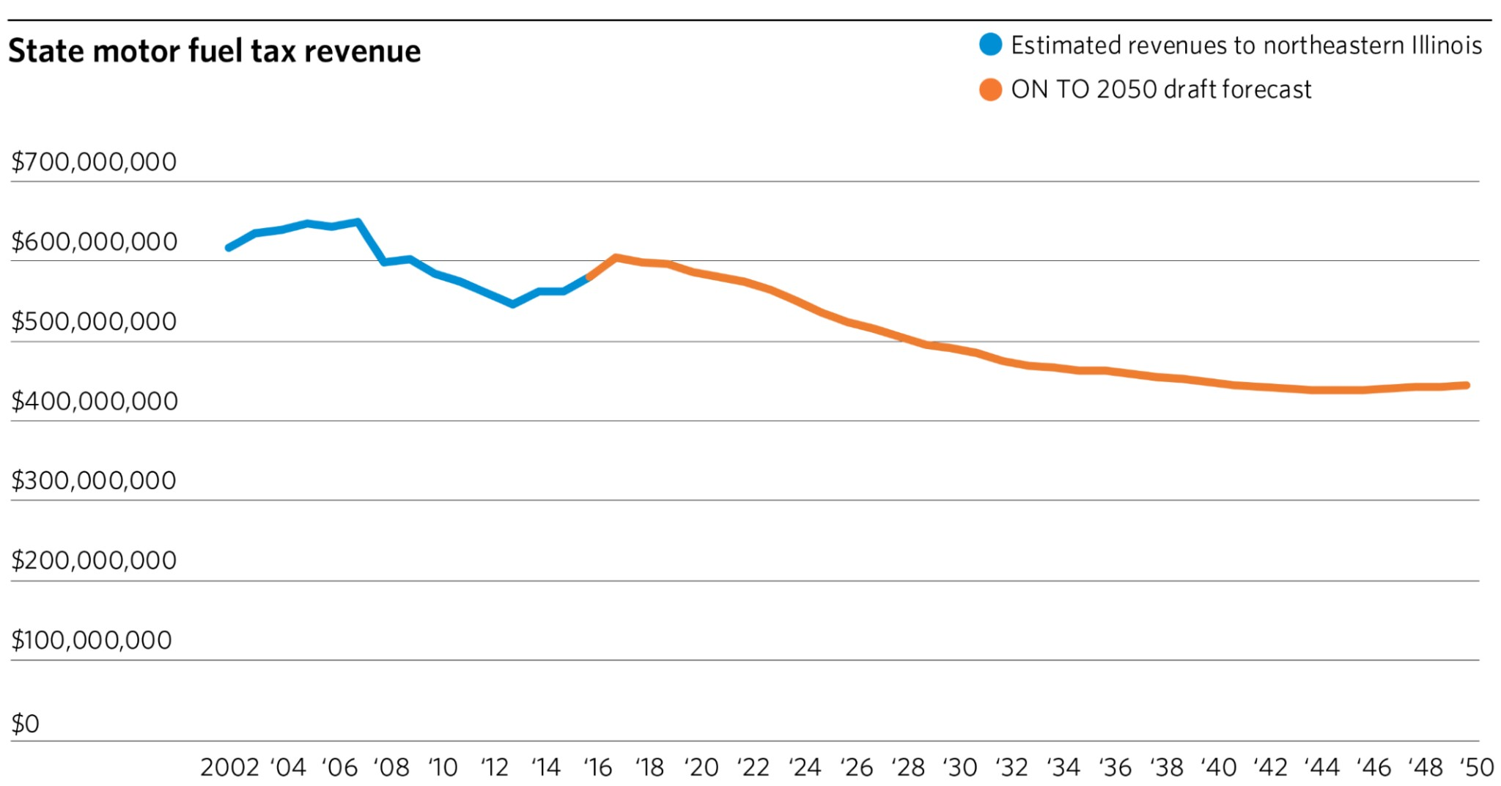
Example: Revenue from the state Motor Fuel Tax is expected to decline.
How do you think your community will respond in a future with less federal and state funding?
- Cuts in local public spending and services
0
%
0
%
0
%
0
%
0
%
0
%
E.
F.
- Higher local taxes and fees
- More coordination with other towns
- Greate^{Subhead goes here}r reliance on private sector partnerships
Fight harder for scarce federal and state dollars Other
What are your top 2 priorities for public funding? (Assume education, public health, and public safety are already priorities.)
  - Transportation
0
%
0
%
0
%
0
%
0
%
0
%
0
%
  - Sewer and water systems
  - Flood controlSubhead goes here
  - Parks and open space
  - Housing
  - Social service programs
  - Other
How should we fund the necessary improvements in our region’s transportation system (select 2)?
0% A. Charge drivers (higher gas tax, tolls, fees)
0% B. Charge more for parking
0% C. Increase sales or property tax
0% D. Raise public transit ^{Subhead goes here}fares
0% E. Charge more to bypass congestion
0% F. Tax properties that benefit from improvements 0% G. Other

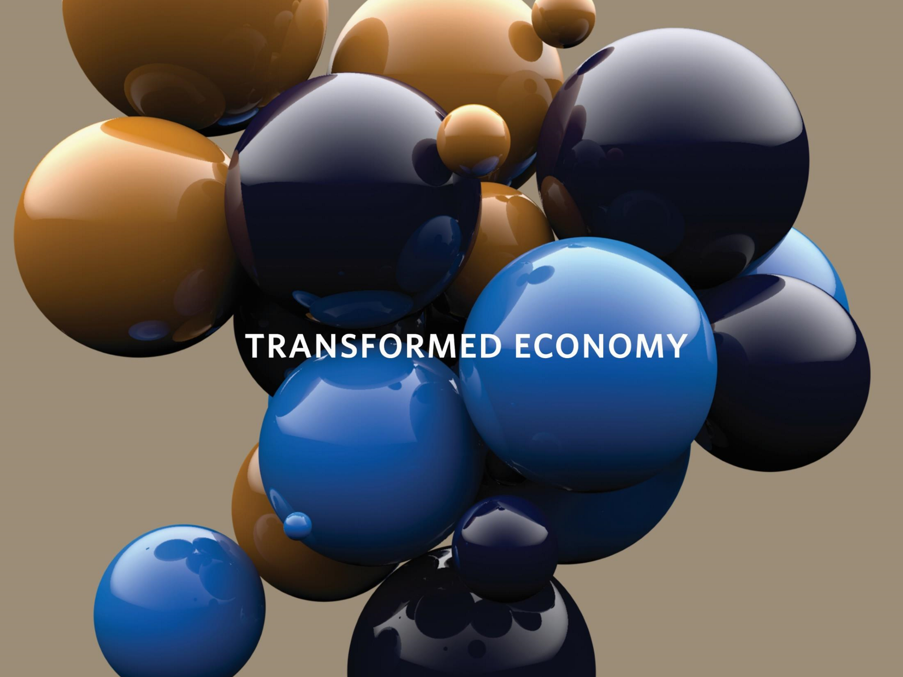

If economic restructuring continues…

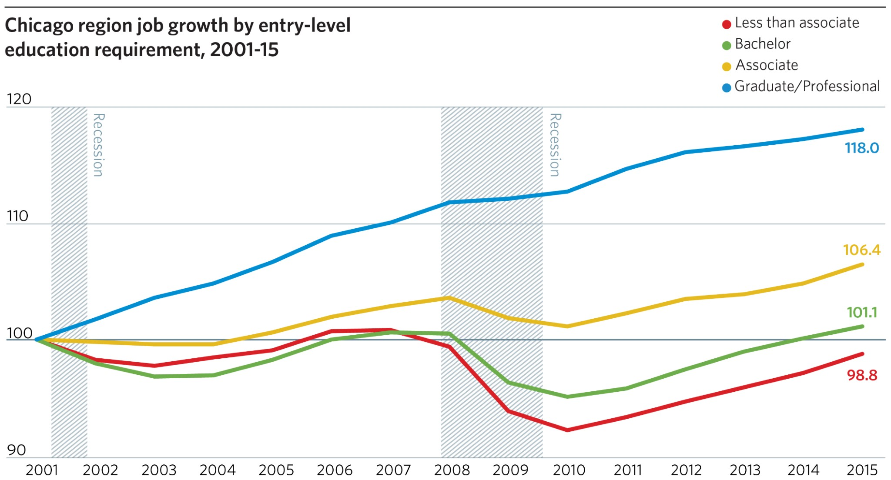
How will technology change jobs in the future?
0% A. More flexibility about when and where people work
0% B. Increased productivity
0% C. Frequent demands for workers to have new skills
0% D. Increased competition for jobs
New opportunities to grow b^{Subhead goes here}usinesses
0
%
0
%
E.
F.
Other
Some workers could fall behind as technology transforms the economy. Which strategies could help?
0% A. Double-down on education
0% B. Connect job training to emerging industries
0% C. Strengthen economically disconnected communities
Create new job opportunitiesSubhead goes here
0
%
0
%
D.
E.
Other
What does our region need most to enable everyone to succeed in the future economy?
0% A. Reliable public transit
0% B. High quality, affordable education
0% C. Continuing job trainingSubhead goes here
0% D. More options to work close to home
0% E. Grow our existing industries
0% F. Easier access to the internet
0% G. Other

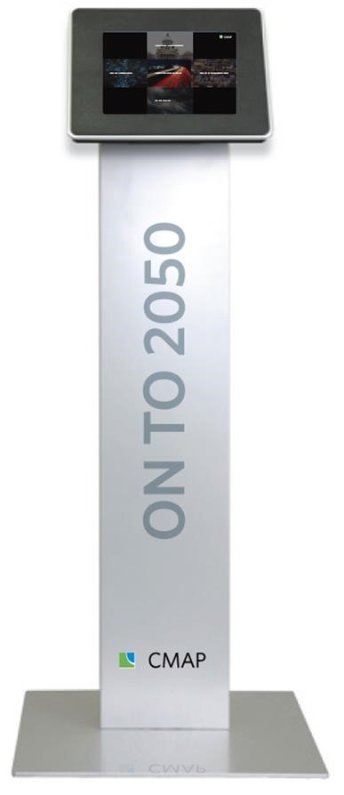
Stay in touch, stay tuned, let us hear from you.
- Email us at onto2050@cmap.illinois.gov
- Subscribe to the CMAP Weekly Update
- Follow us on Twitter
@ONTO2050, like us on
Facebook, and share your
#2050BigIdeas
- Visit cmap.illinois.gov/onto2050/futures for links to videos, more surveys

Imagine our Future
Changed Climate
Walkable Communities
Innovative Transportation Constrained Resources Transformed Economy
Where do we want to be in 2050?

